**Distance Learning Centre**

**Ahmadu Bello University, Zaria. Nigeria.**

**Programme: MPH Date: 4th JULY 2022**

|  |  |  |  |
| --- | --- | --- | --- |
| |  |  |  | | --- | --- | --- | | |  |  | | --- | --- | | |  | | --- | | **Name: Frank Bokime Eli**  **Registration Number: P21DLPH80071** | | | |

**COURSE DEFEREMENT REQUEST**

Your request for course deferment of the following courses:

1. **COMM 811 ( Biostatistics 1)**
2. **COMM 821 ( Non- Communicable Disease Epidemiology)**

**3. COMM 801 ( Basic Epidemiology)**

registered in the January 2021/2022 semester has been approved at your expense and no further commitment from the school.

You would be expected to register in the next Semester or whenever convenient.

With Compliments.

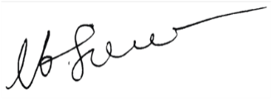

Prof. M. I. Sule

(Director, DLC)