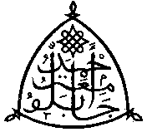**Distance Learning Centre**

**Ahmadu Bello University, Zaria. Nigeria.**

|  |  |  |  |
| --- | --- | --- | --- |
| Programme: **Masters in International Affairs and Diplomacy (MIAD)**  Date: **20th October, 2022**   |  |  |  | | --- | --- | --- | | |  |  | | --- | --- | | |  | | --- | | Name: **Chioma Nneka Uwalaka**  Registration Number: **P21DLPS80202** | | | |

**SEMESTER DEFEREMENT REQUEST**

Your request for deferment of the May Semester 2022 Examination has been approved at your expense and no further commitment from the School. You would thus be expected to register for the next semester or at your convenience.

The courses are: MIAD 818; MIAD 820

With Compliments.

Professor Mohammed Ibrahim Sule

Director, Distance Learning Centre

Ahmadu Bello University, Zaria.