**Distance Learning Centre**

**Ahmadu Bello University, Zaria. Nigeria.**

**Programme: B.NSc Date: 29/12/2021**

|  |  |  |  |  |
| --- | --- | --- | --- | --- |
| |  |  |  |  | | --- | --- | --- | --- | | |  |  |  | | --- | --- | --- | | |  | | --- | | **Name: Usman Musa**  **Registration Number: U18DLNS20156** | |  | | | |

**COURSE DEFEREMENT REQUEST**

Your request for course deferment:

(NURS 502, NURS 504, NURS 506,NURS 508, NURS 512, NURS 516, PATH 312 and NURS 306

has been approved at your expense and no further commitment from the School.

You would be expected to take it in the next Semester or whenever convenient.

With Compliments.

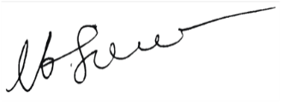

Prof. M. I. Sule

(Director, DLC)